Overview of Malaysia and its UBF chapters
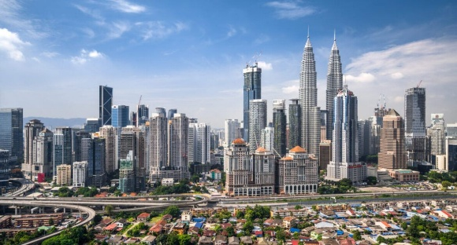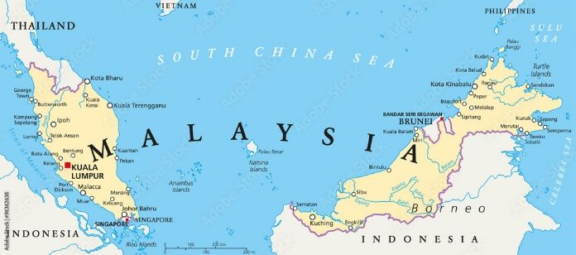
Malaysia is ethnically and culturally diverse, with a population of over 34 million people. The religious identity maps closely to the ethnicity and region. Peninsular Malaysia (where Kuala Lumpur is located) is dominated by Malay (Muslims), Chinese (either Buddhist, Taoist or Christians) and Indian communities (mostly Hindus with pockets of Christians). In East Malaysia (where Sabah and Sarawak states are located), have many indigenous groups (Kadazan, Iban, Bajau, Bidayuh, Melanau, etc), which have a higher Christian representation. Despite its diversity, Islam is the official religion of the country as >60% of the population are Muslims. Nonetheless, it is a strategic place to many people with diverse backgrounds with the gospel. In terms of the economy, Malaysia is an open, export-oriented, middle-income market, driven mainly by services and manufacturing, which attracted a large migrant population, including Koreans. In terms of the geography, Malaysia is a tropical country with generally less severe natural disasters such as hurricanes, earthquakes and tsunamis.
UBF Malaysia started in 2011 through the co-working of Malaysian shepherds, Ison Hong (I) and Vincent Lee (V), following I’s campus mission work at the Illinois Institute of Technology (IIT) and Springfield UBF and V’s baptism at the Hyde Park UBF and graduation from UChicago.
Beginning with a focus on a top public university in Kuala Lumpur (KL), named University Malaya, the ministry has since extended to include Sunway University, a private institution, where S. Becky is teaching. This growth was further established through house churches: S. I and S. Becky (from Taiwan) in 2017, and S. V and S. Carole in 2018. Together, the two families have been worshipping together in a rented office suite, serving campus students from all over the world as well as fellow colleagues at work, while raising a total of four children. Since 2024, as drug abuse becomes a major problem for the younger generation, the ministry has started serving a Christian drug rehab with monthly evening sermons.
Beyond the capital, the mission extends to East Malaysia with a Korean missionary family (M. Andrew and Anna Jung) serving in the state of Sabah, where M. Anna teaches Korean at a local university. They pray to serve their communities faithfully with their five loaves and two fish.

